Sergey Gasparyan 1
Sergey Gasparyan
Danielle Crawford
Writing 2
24 April 2017
Narrative
As I walked down the sidewalk toward the entrance of Cowell Beach, I could see a
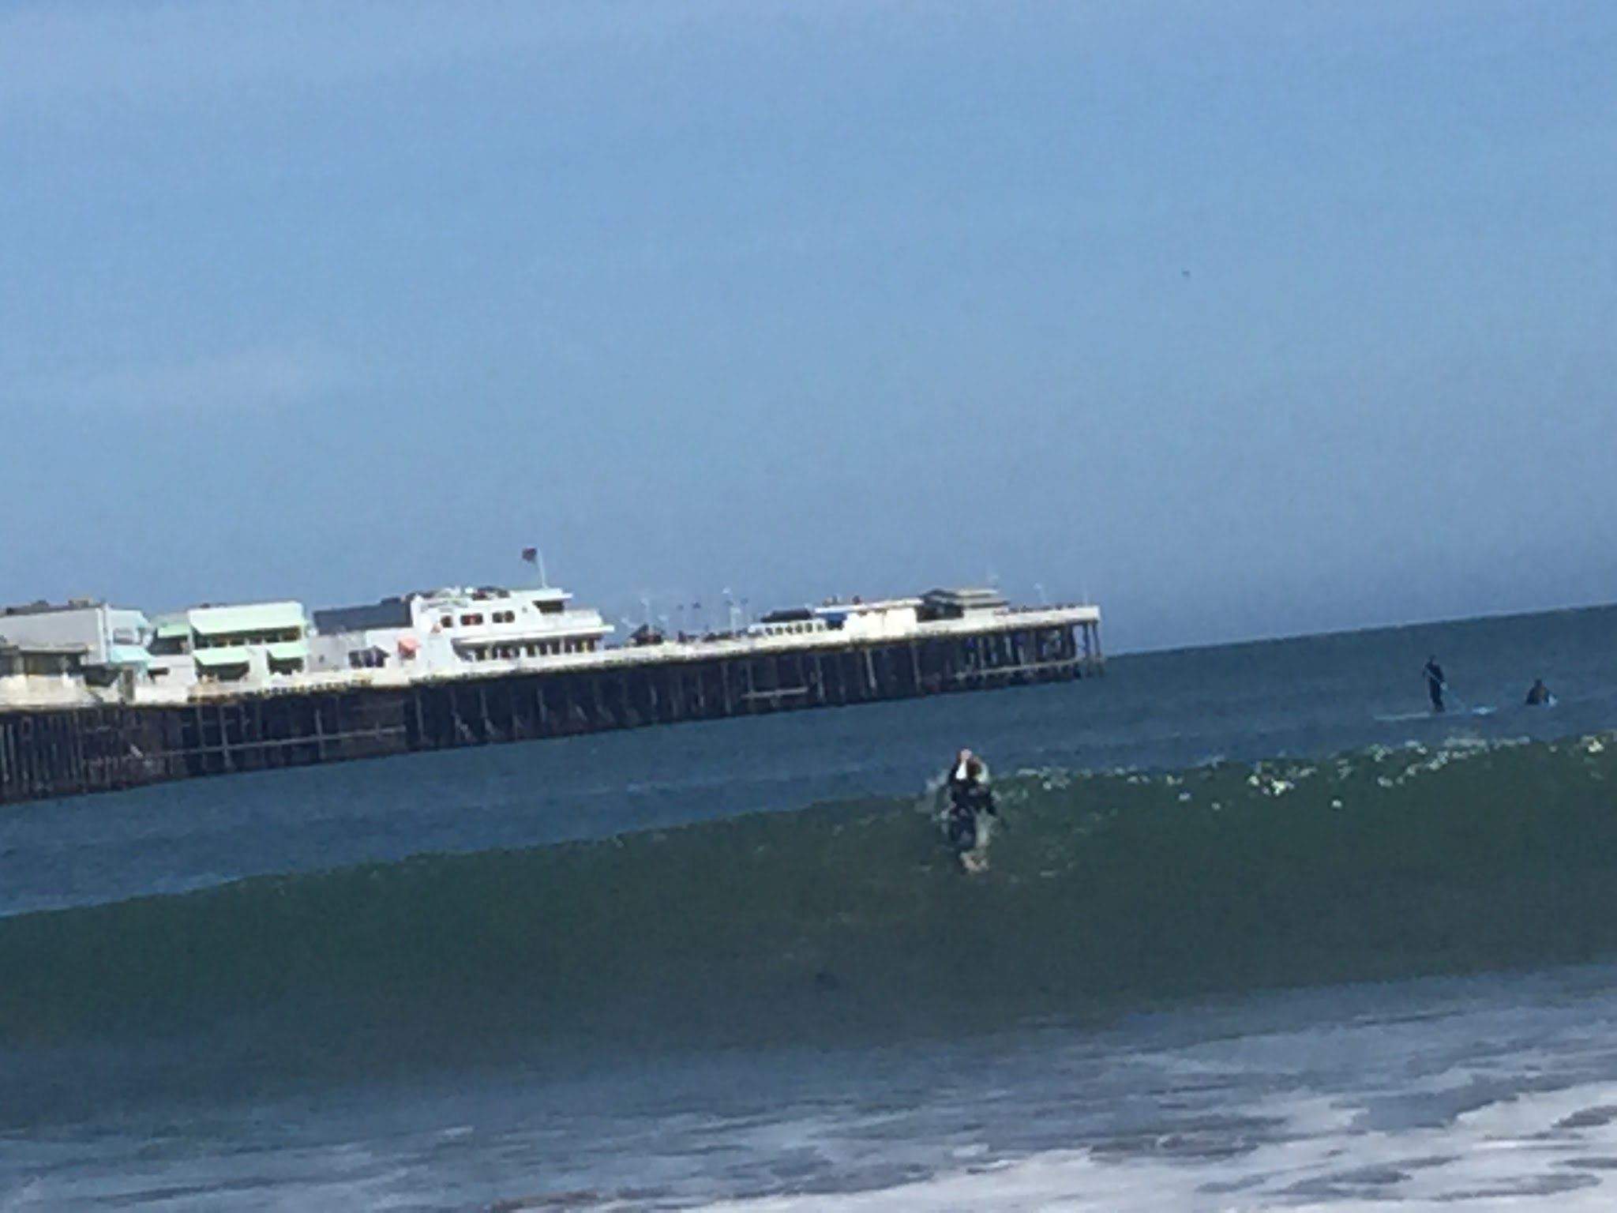
multitude of people waiting in the water for the upcoming wave. As the wave approached, the surfers, like a group of ants, rushed to keep at its fast pace. Many were unable to make it on time, but the lucky few soared across the gleaming water until the wave consumed them. The sound of the crashing wave startled me, and I looked down to realize that I had arrived at Cowell Beach. I took off my shoes before entering the beach, and felt the tingling sensation of sand rubbing against the bottom of my feet. I looked up at the sky and saw the blazing sun pounding down the 80-degree weather that I had missed so dearly this winter. The sunlight glistening off the sand, made me feel as though I was walking through a garden of gems. As I looked down at my feet, I noticed a plastic bottle that had been left by a previous visitor. The sight of the litter showed me that the problems this beach had when I visited it as a child have not be fixed. The nearest trash cans were placed next to the entrance and there
Sergey Gasparyan 2
did not seem to be any signs warning people to not ruin this magnificent beach.
I started my adventure by walking from one side of Cowell Beach to the other side of the
Boardwalk Beach. The trek lasted around 15 minutes, but the countless sights I witnessed made the journey feel effortless. As I walked along the shoreline, I saw the happy and ecstatic faces of young children dipping their feet in the cold and salty ocean water. As a wave approached the shore, they all ran in terror at its sight, hoping to not get pulled into the ocean by the rip current. The older kids were braver and attempted to run into the wave, only to be swallowed by its massive force. After a couple of seconds, their heads would pop up out of the water with an overjoyed grin.
A couple of meters away from them, there was a group of young girls building a sand castle with their younger siblings. The structure was just getting started, but I could tell that the result would be impressive, because of the teamwork the collective demonstrated. The younger kids would fill the buckets with sand and the older girls would build the castle. Their parents were a couple of feet away from them, sitting on a towel with a variety of snacks and drinks. A bag of Tostitos chips lay on its side spilling all over the sand near their picnic. I hoped that they would throw away their trash and clean up after they were done with it.
As I walked closer to the other end of the beach, I saw a myriad of individuals taking selfies under the pier and enjoying the shade that it offered. Next to these delightful faces, lay a couple of homeless people who had no other place for shelter. I felt sad seeing their predicament, but walked past without giving them some spare change. As I approached the Boardwalk Beach, I immediately noticed a flock of seagulls circling above a picnic. As the people stood up to go towards the water, the seagulls pounced on the food and took a bag of cheese puffs. The bird that had the bag in his beak was unable to leave the ground, because of its weight and had to drop it. As the bag dropped onto the sand, all the
Sergey Gasparyan 3
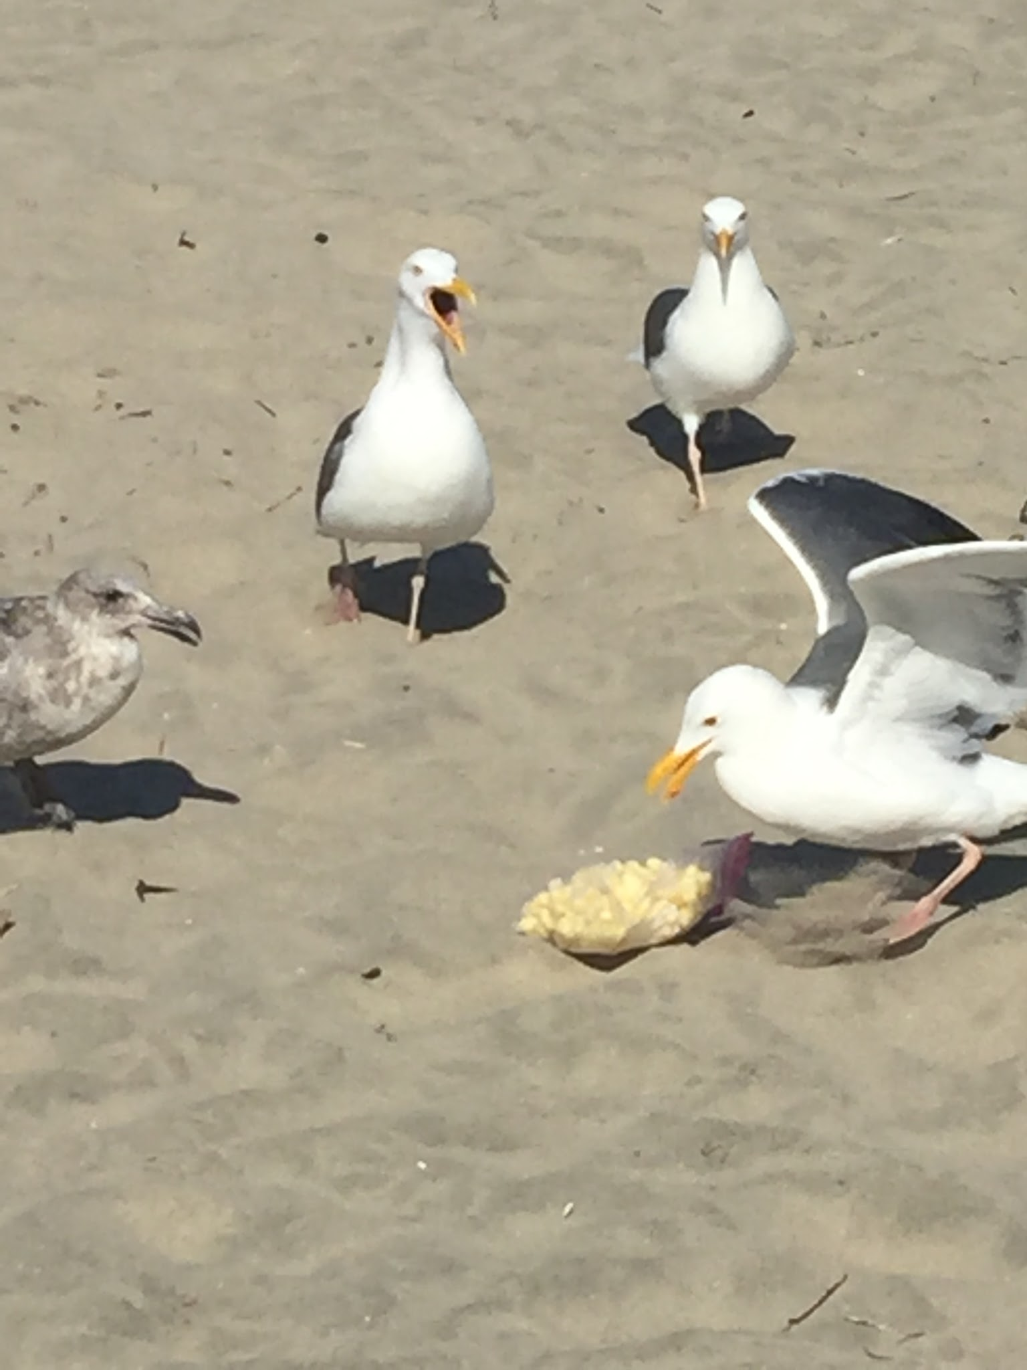
seagulls dove at it and began to fight for a share of the spoils. They pecked at each other and the bag moved from the mouth of one seagull to the other, until it was torn apart and all the cheese puffs fell out. Soon after, the birds all flew up again and traveled to find the next picnic that they could snag food from. The family came back to their picnic and continued with their day, not acknowledging the incident that had just occurred.
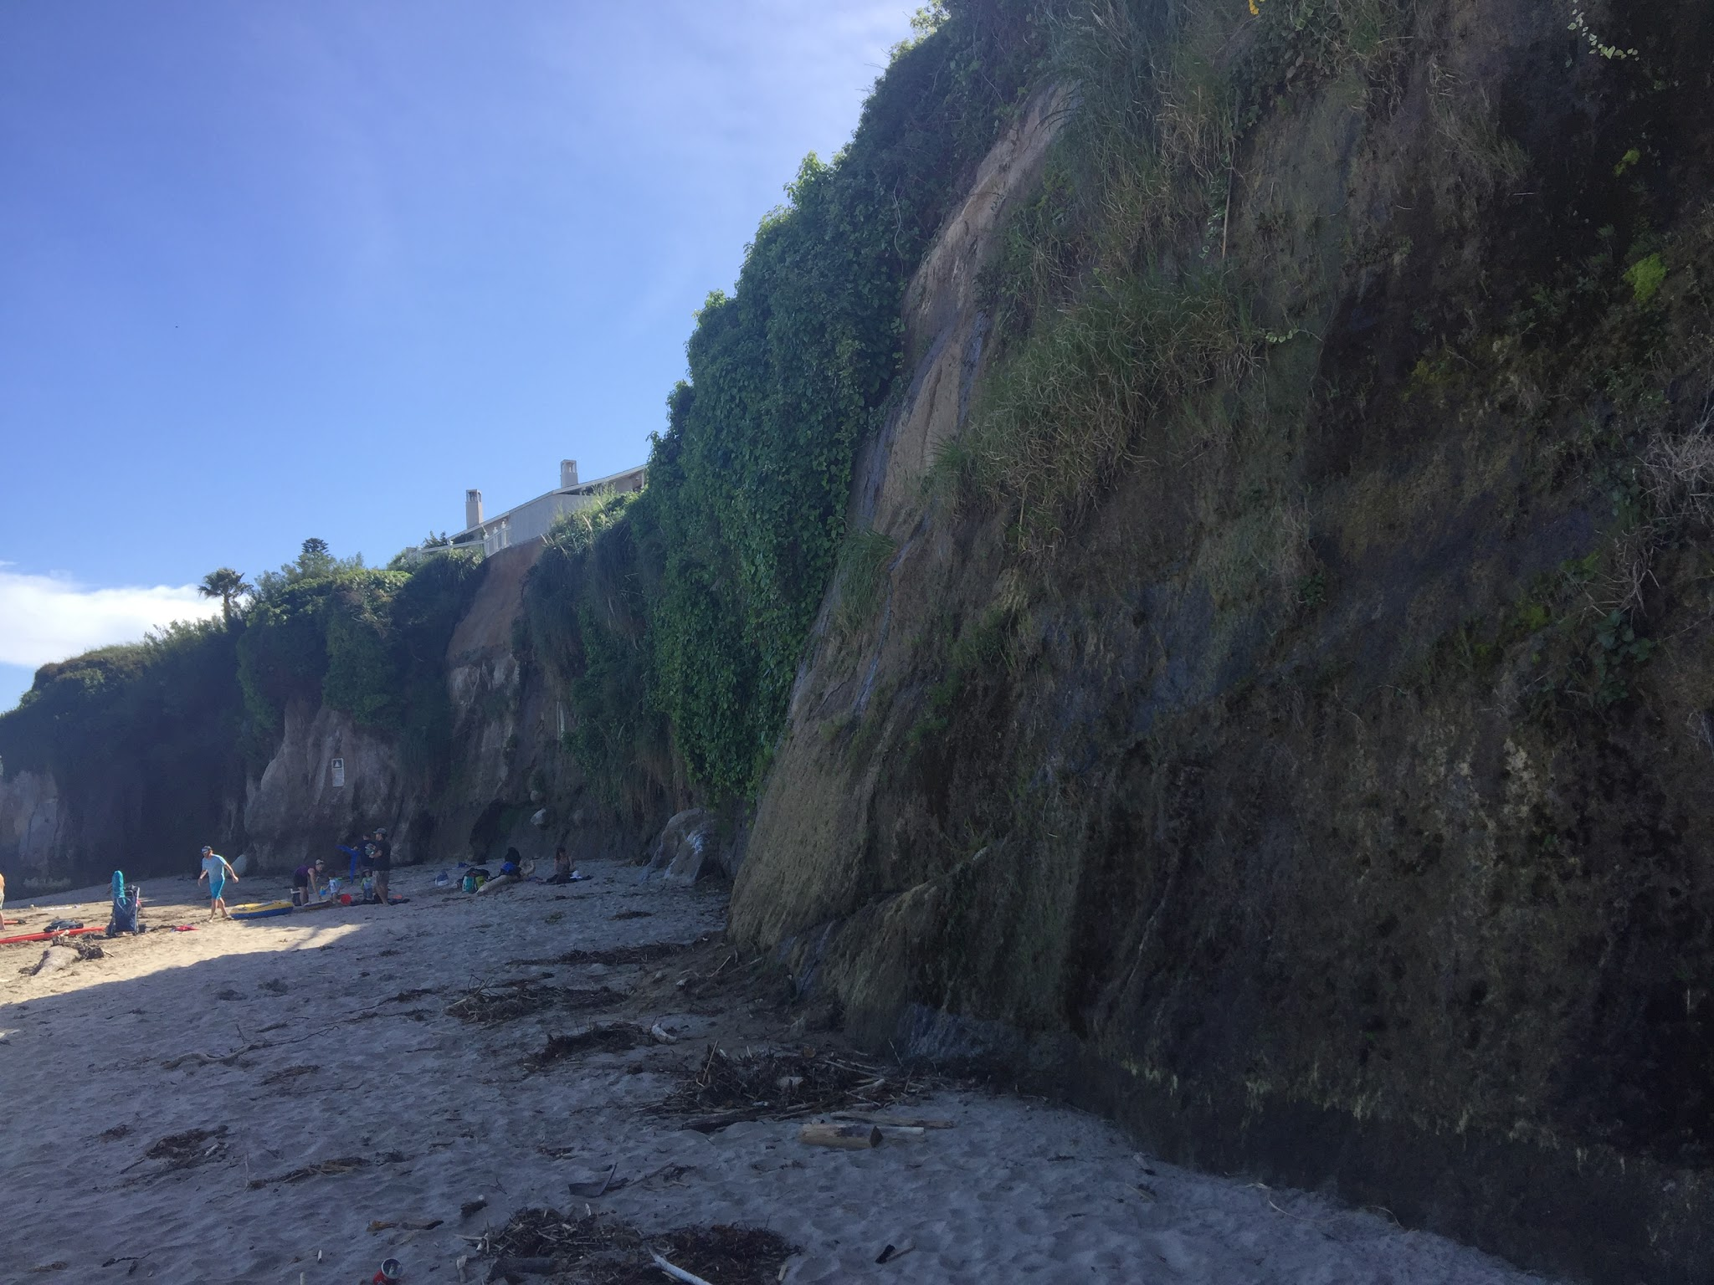
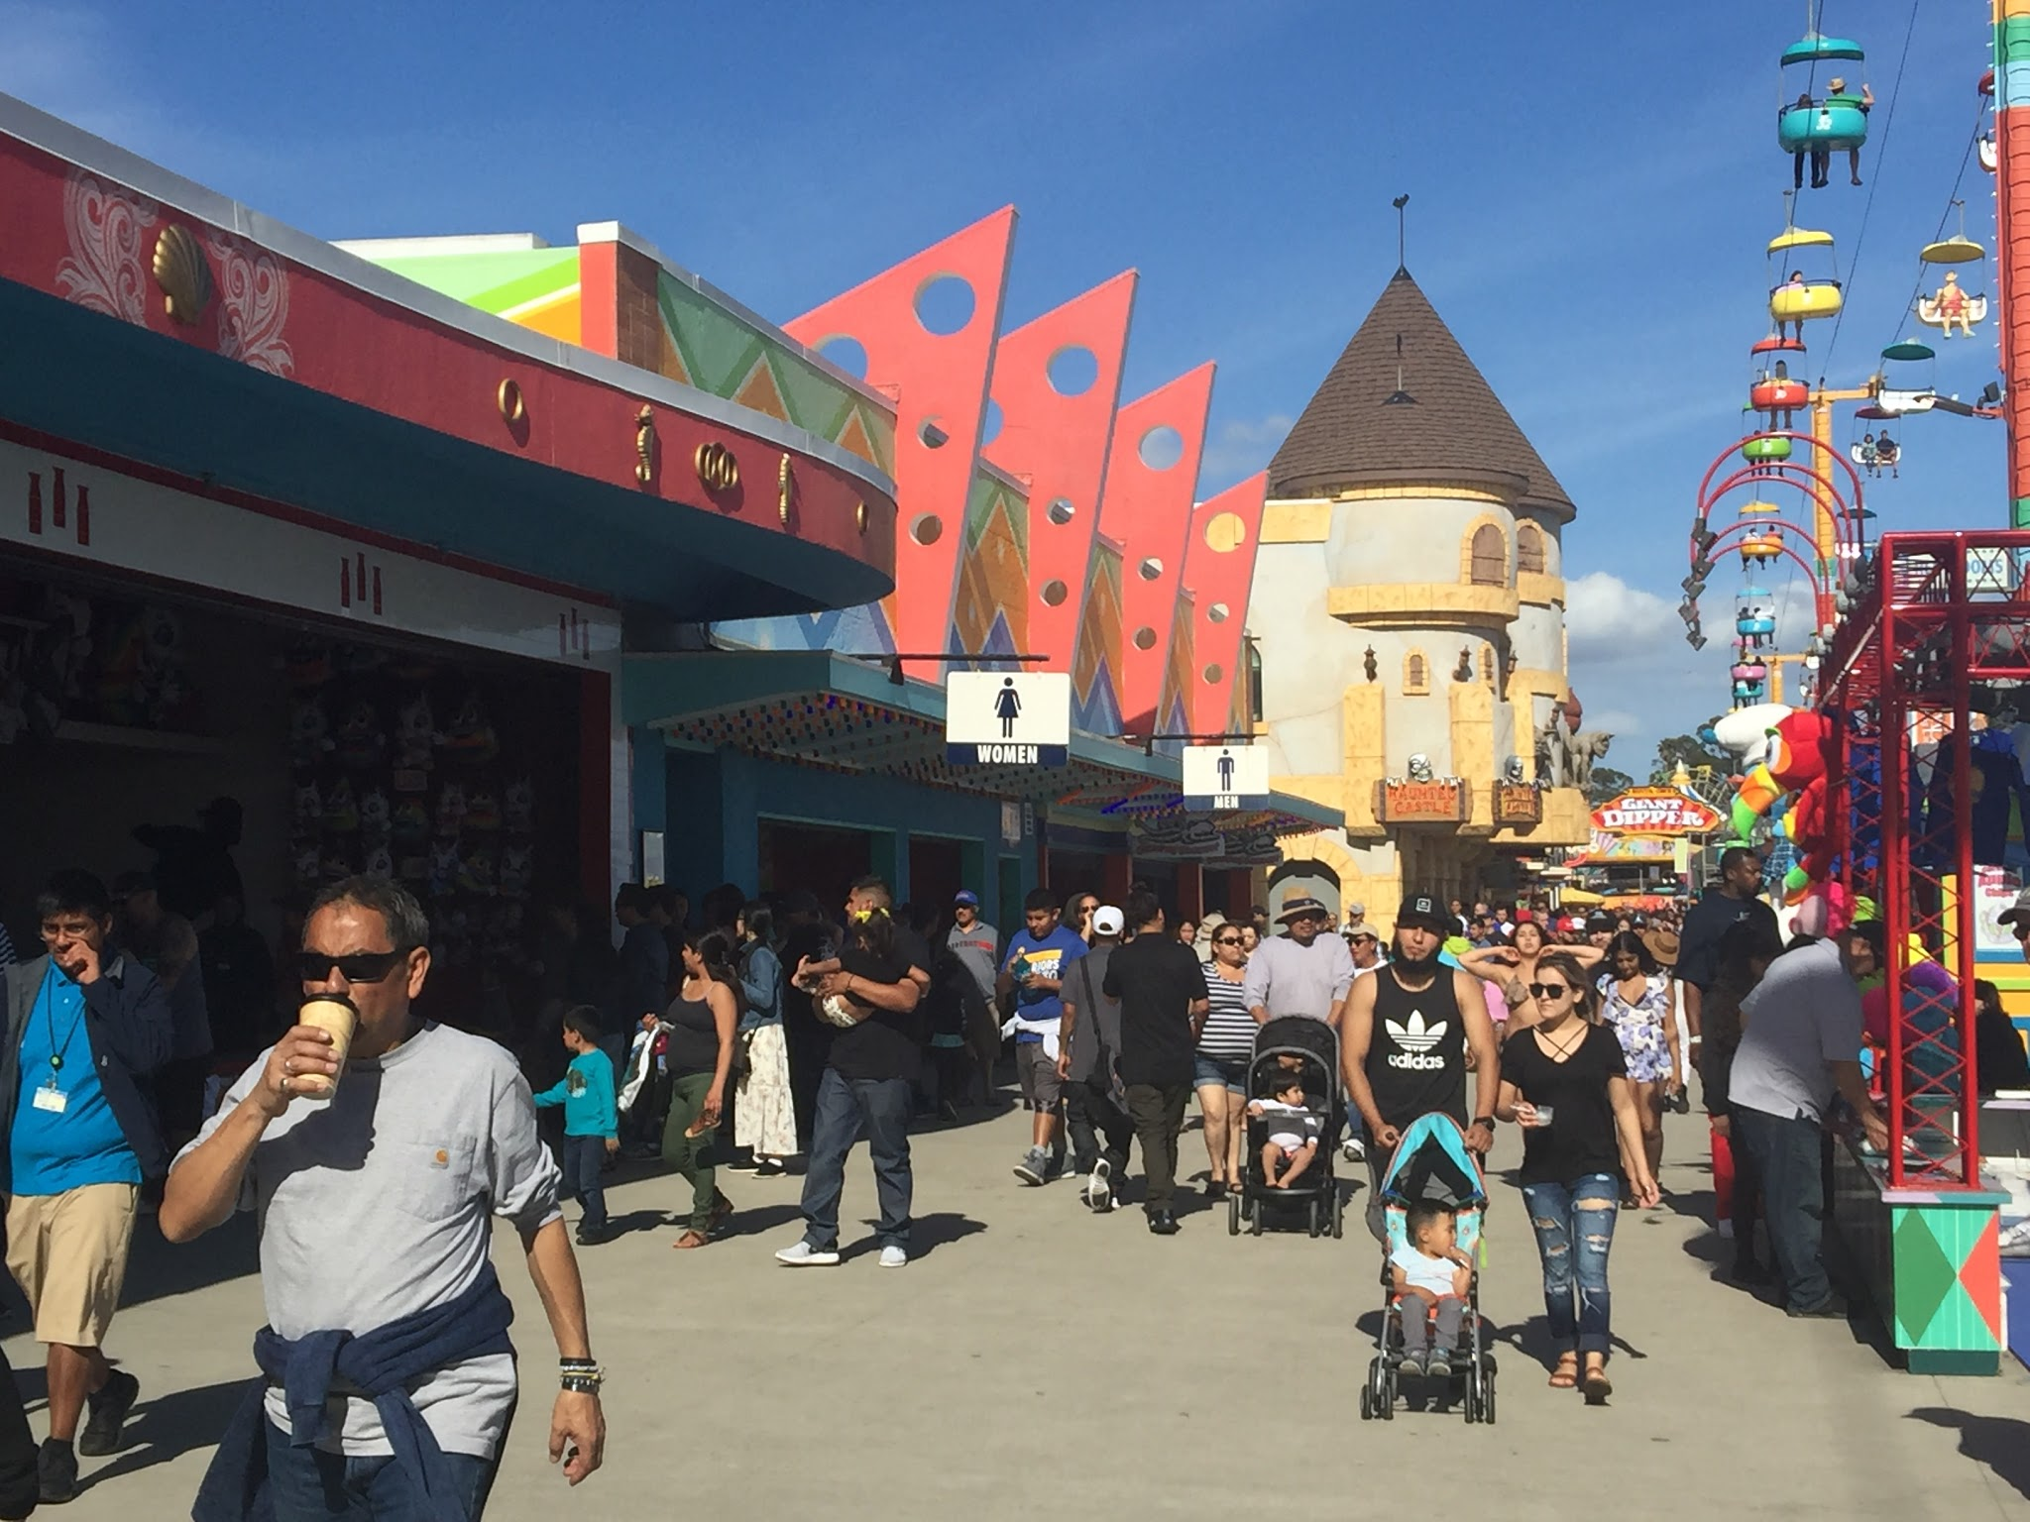
My concentration was broken by the screams of children riding the drop tower. I looked toward the boardwalk and felt nostalgic about all the good times I’d had there. I could hear the Beach Boardwalk commercials from my childhood in the back of my head, reminding me how excited I was to visit this same beach 10 year ago. The litter on the Boardwalk Beach was much worse than the litter on Cowell Beach. Every 20 feet there was another water bottle or paper cup laying there in the sand, waiting to pollute the beach. The beach was crowded with people and it seemed impossible to relax. I felt as if I was at a public pool, waiting for everyone to leave so I could finally enjoy the water. I walked up to the ocean and put my right hand into the wave that just broke onto the shore. The water was much colder than I had anticipated and reminded me why I never had swum in this beach before. The water had a brownish tint to it and it seemed unsanitary. There were few people in the ocean on the Boardwalk Beach. Most of them were either sitting on towels or playing a sport of their choosing. A group of teenagers were attempting to boogie board on the waves, but the waves would crash to suddenly and submerge them underwater.
Sergey Gasparyan 4
I began to see the caves I visited as a child, as I approached the end of the Boardwalk Beach. There was a stream rushing past them and they seemed impossible to get to. I was disappointed by this, because these caves were my favorite part of the boardwalk experience. I still remember seeing my first seal in these caves and being amazed by its beauty. Since I was unable to enter the caves, I decided to walk up the river that went by them and see if I can climb up to some higher ground. I wanted to get a good view of the whole boardwalk and take it all in at once. I began to climb one of the small cliffs that surrounded the beach. The climb was relatively easy, but the constant slipping of rocks made me think that I was about to start an avalanche. When I got to the top I was about 30 feet above the beach. Orange and purple flowers surrounded me along with a bunch of tall grass. I looked from one side to the other and felt a sense of satisfaction. I was unable to stay up on the view point for too long, because there were tons of bugs in the tall grass and I could feel them attempting to suck the blood out of me.
After climbing down the cliff, I walked back into the Boardwalk and decided to get an Icee. The Icee, although costing six dollars, was the perfect beverage to quench my thirst. The cold slushy texture melted in my mouth and made me feel cool under the hot spring sun. As I sat on a bench drinking my Icee, I watched hundreds of delighted faces walk from one ride to the other. The older kids who did not
want to go on the roller coasters spent most of their time on the different games the Boardwalk had to
Sergey Gasparyan 5
offer. I watched as a group of teenagers, attempting to win themselves a soccer ball, miss the required target by an inch. They looked disappointed after their efforts were determined to be futile and seemed to decide that they would instead go win a basketball. In my youth, the basketball game was my favorite, because it was the only one I could win from time to time. The game costed five dollars and every ball you made in the hoop was a free basketball. I would spend over 20 dollars playing this game every time I visited the Boardwalk, and usually would come home with three or four brand new basketballs. The group of adolescents took turns shooting three balls and in the end, they had collected a total of five balls. Content with their winnings, they walked away from the carnival games and disappeared into the crowd.

